
Phase 2 Report
Project Title
PREDICTIVE ANALYTICS FOR URBAN WATER DEMAND
Problem Id: 06

Name: Nitin Singh
University Roll No: 2028786
Sec: Q

Name: Rohan Prasad Tiwari
University Roll No: 2028825
Sec: Q

Name: Ashutosh Singh
University Roll No: 2028675
Sec : Q

- Problem Description ............................................................................................... 3
- Architecture ............................................................................................................ 4
- Models Used................................................................................................. 5
- Evaluation metrics used .............................................................................. 6
- Preliminary Results and Visualizations ..................................................... 7
- References ...................................................................................................... 9

1.Problem Description

Urban areas are facing increasing challenges in managing water resources due to rapid

population growth, changing lifestyles, and seasonal variations. Efficient prediction of

daily water consumption is essential for proper planning, conservation, and distribution of

water. Traditional estimation methods are often inaccurate and do not consider multiple

influencing factors.

This project focuses on developing a machine learning-based system to predict daily

water usage using features such as household size, seasonal index, and garden area. By

analyzing historical data, the model identifies patterns and relationships between these

factors and water consumption.

The system uses data preprocessing, feature selection, and regression techniques to build

an accurate prediction model. The results help in understanding water usage trends and

improving decision-making.

In real-life applications, this model can assist municipal authorities in optimizing water

supply systems, reducing wastage, and ensuring efficient resource management. It can

also help households monitor and control their water usage. Overall, this project

contributes to sustainable water management and smarter urban planning.

2.Architecture


Start
Load Dataset (CSV File)
Data Preprocessing (Fill missing
values)
Feature Selection
Household_Size, Seasonal_Index
(
)
Train
-
Test Split (70% Train, 30%
Test)
Model Training (Linear
Regression)
Prediction (y_pred)
Evaluation (R2 Score, MAE, MSE)
Visualization (Scatter Plot)
End

3.Models Used (Applied/ Planned) :
• Linear Regression Model
Linear Regression is a supervised machine learning algorithm used to predict continuous values. It establishes a relationship between independent variables
(features) and a dependent variable (target) by fitting a linear equation.
In this project, Linear Regression is used to predict daily water consumption based on features such as household size, seasonal index, and garden area. The model learns patterns from the training data and then predicts water usage for new inputs.
The simplicity and efficiency of Linear Regression make it suitable for this project, as it provides good accuracy and is easy to interpret. It also helps in understanding how each feature affects water consumption.

4.Evaluation metrics used

- R² Score (Coefficient of Determination)

R² score measures how well the model explains the variance in the target variable. Its

value ranges from 0 to 1, where values closer to 1 indicate better model performance.

- Mean Absolute Error (MAE)

MAE calculates the average absolute difference between actual and predicted values.

Lower MAE indicates better accuracy.

- Mean Squared Error (MSE)

MSE measures the average squared difference between actual and predicted values. It

penalizes larger errors more than MAE. These metrics help in understanding the

accuracy and reliability of the prediction model.

- Preliminary Results and Visualizations

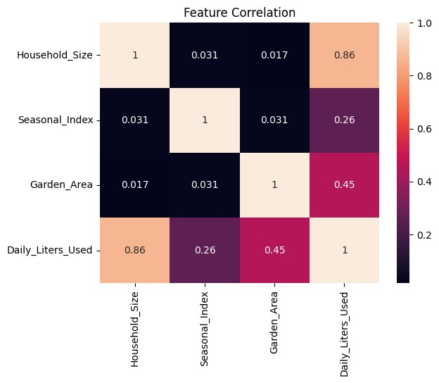

Heatmap showing correlation.

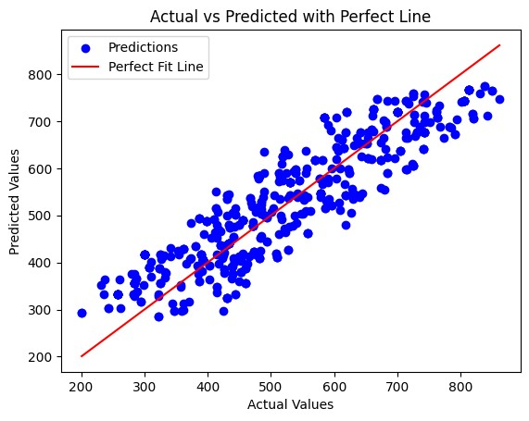

R2 Score: 0.81
MAE: 56.32
MSE: 4320.41
Accuracy: 81.1 %

- References:
Books:
  - Let Us Python – Yashavant Kanetkar
  - Hands-On Machine Learning with Scikit-Learn – Aurélien Géron

Online Resources:
  - https://www.geeksforgeeks.org/
  - https://scikit-learn.org/

